ST. MICHAEL’S CATHOLIC GRAMMAR SCHOOL

Nether Street 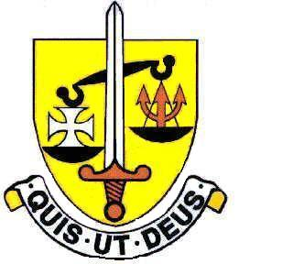 Voluntary Aided
North Finchley “An outstandingly effective School” Ofsted

London N12 7NJ
Tel: 020 8446 2256 Email: office@ st-michaels.barnet.sch.uk
Fax: 020 8343 9598 Website: www.st-michaels.barnet.sch.uk

4 Form Entry Voluntary Aided Grammar School for Girls with Boys in the Sixth Form
890 on Roll. 250 in Sixth Form.

Technician Food & Nutrition, Part-time 22 hours per week, 39 weeks per year (term time only)
Unified Rewards Grade C: Actual Salary £16,464 to £16,702 (£30,630 to £31,074 FTE)
(Pay Award pending)
Required as soon as possible

The Governors are seeking to appoint a Technician to provide specialist support to our Food & Nutrition Department at this selective school, FIVE times judged OUTSTANDING by OFSTED (the most recent Inspection being November 2022), which is committed to the ideals of Catholic education and where GCSE and A Level results are consistently excellent.

Duties are wide-ranging and will include: support to pupils in accessing the curriculum (experience in food/catering/cooking is required), maintenance, cleaning, and preparation of equipment/working areas/resources, shopping for/ordering ingredients. Knowledge of food hygiene standards (training is available). The Food Technician enables the smooth running of lessons.

This person will work under the direction of the Head of Food and Nutrition. School experience would be desirable but is not essential. Students at the school are very well behaved and the school is a very pleasant environment. The school provides a very rewarding working environment where employees are valued and there is a focus on staff welfare.

The appointed candidate will be flexible in their approach to the wide-range of work undertaken – and will be an intrinsic part of the support staff team. The ability to manage a range of competing demands and to prioritise work is very important. Very good levels of both written and spoken English are essential together with computing skills.

An application form and job description are available on the school website.

Please send completed applications to applications@st-michaels.barnet.sch.uk.

Closing date: Monday 22nd September midday – early applications are encouraged as we reserve the right to call candidates to interview before this advert is withdrawn.

We are committed to safeguarding and promoting child welfare
The post is subject to an enhanced DBS check
St. Michael’s is committed to equal opportunities, we welcome applications from all sections of the community

