ST. MICHAEL’S CATHOLIC GRAMMAR SCHOOL

Nether Street 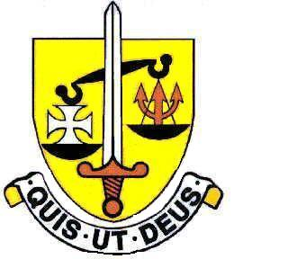 Voluntary Aided
North Finchley “An outstandingly effective School” Ofsted

London N12 7NJ
Tel: 020 8446 2256 Email: office@ st-michaels.barnet.sch.uk
Website: www.st-michaels.barnet.sch.uk

4 Form Entry Voluntary Aided Grammar School for Girls with Boys in the Sixth Form.
850 on Roll. 250 in Sixth Form.
Peripatetic Singing Teacher
The school is seeking an experienced and inspirational singing teacher to join the Music Department from April 2023.

The successful applicant will be an outstanding singer and singing teacher who enjoys working with young people. Experience of teaching singing to students at a secondary school age from beginner to Grade 8 is essential. Experience of preparing students for ABRSM examinations, and the performing requirements of GCSE Music, is highly desirable. Peripatetic teachers at St. Michael’s Catholic Grammar School are self-employed and work closely with the school and parents. The hourly rate for instrumental and vocal tuition from September 2022 is £39.00. We expect there to be at least a full day of teaching available (possibly two full days).

St. Michael’s is a selective school with a distinctive Catholic ethos. Students are very well behaved and the school is a very pleasant working environment. Music is well-established within the school, with frequent performance opportunities available to students. The department currently comprises the Director of Music and 14 self-employed peripatetic music teachers. The department has five air-conditioned practice rooms available for instrumental/vocal lessons, a large class teaching room, and drum room. There are a broad range of extra-curricular opportunities available to students, including two orchestras, two choirs, Jazz Band, Flute Ensemble and a Wind Ensemble. There are ensemble concerts, Chamber Concerts for soloists and small ensembles, and musical theatre productions. Music plays an important role in the Catholic life of the school, and the department has a history of concert tours to Europe such as Prague and Amsterdam. An ABRSM Private Visit is organised annually.

Interested teachers should complete the Teaching Staff Application Form on the school website. Please send completed applications to applications@st-michaels.barnet.sch.uk.
Closing date: Monday 20th March 2023 midday
A suitable candidate may be appointed before the closing date, so an early application is advised. Shortlisted candidates will be invited to interview.
Part of the process will include a short singing lesson with one of our students.

We are committed to safeguarding and promoting child welfare. The post is subject to an enhanced DBS check. St Michael’s is an equal opportunities employer - applications are welcome from all sections of the community

