ST. MICHAEL’S CATHOLIC GRAMMAR SCHOOL

Nether Street 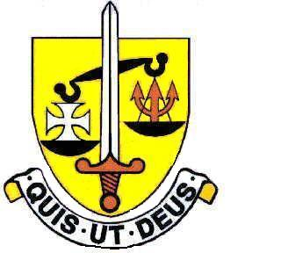 Voluntary Aided
North Finchley “An outstandingly effective School” Ofsted

London N12 7NJ
Tel: 020 8446 2256

Email: applications@st-michaels.barnet.sch.uk

4 Form Entry Voluntary Aided Grammar School for Girls with Boys in the Sixth Form
850 on Roll. 240 in Sixth Form.

Teacher of Girls’ P.E.
Salary - Main or Upper Scale

To start 1st September 2023

The Governors are seeking to appoint an enthusiastic teacher of Physical Education to join an experienced and successful department, delivering a wide variety of P.E. and recreational activities throughout the school. A second subject would be advantageous. A commitment to team games and extra-curricular activities is essential as the school enjoys a high reputation for competitive sports.

Applications from Early Careers Teachers are welcome - the person appointed is expected to be able to teach up to GCSE.

The ideal candidate will enjoy the challenge of teaching well-behaved, enthusiastic and able pupils in this selective school committed to the ideals of Catholic education and 5 times judged ‘Outstanding’ by OFSTED, the most recent inspection being November 2022.

The school provides a very rewarding working environment where employees are valued and there is a focus on staff welfare.

An application form and job description are available on our website.

Please send completed applications to applications@st-michaels.barnet.sch.uk.

Closing date: Tuesday 18th April 2023 9am – Early applications are encouraged as we reserve the right to call candidates to interview before this advert is withdrawn.

We are committed to safeguarding and promoting child welfare
The post is subject to an enhanced DBS check
St. Michael’s is an equal opportunities employer - applications are welcome from all sections of the community

