ST.MICHAEL’S CATHOLIC GRAMMAR SCHOOL

Nether Street 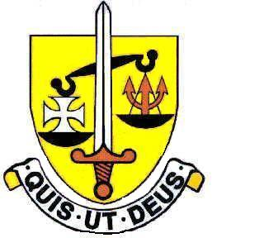 Voluntary Aided
North Finchley “An outstandingly effective School” Ofsted

London N12 7NJ
Tel: 020 8446 2256

Email: applications@st-michaels.barnet.sch.uk

4 Form Entry Voluntary Aided Grammar School for Girls with Boys in the Sixth Form
850 on Roll. 240 in Sixth Form.

Lunchtime Supervisor, 7.5 hours per week, core hours 12.45 to 2.15pm Monday to Friday
39 weeks per year, Unified Reward Grade A
(£23,457 to £24,804 FTE) – Actual salary £4,279 to £4,524

Required as soon as possible.

The Governors are seeking to appoint a Lunchtime Supervisor to assist in achieving an appropriate environment for students during their lunchbreak.

Ideally suited to this role would be someone with excellent communication skills who can maintain good order while remaining calm and patient - an enthusiastic outlook is important, this person must be a positive role model for the students.

The appointed person will assist in ensuring school rules are followed and the environment is kept pleasant for all whilst providing effective communication in accordance with safeguarding and health and safety requirements.

Closing date: Friday 21st April midday - Interviews the following week. Early applications are encouraged as we reserve the right to call candidates to interview before this advert is withdrawn.

A Support Staff application form and Job Description are available on our website.

Please send applications to applications@st-michaels.barnet.sch.uk

We are committed to safeguarding and promoting child welfare
The post is subject to an enhanced DBS check
St Michael’s is an equal opportunities employer - applications are welcome from all sections of the community

