ST. MICHAEL’S CATHOLIC GRAMMAR SCHOOL

Nether Street 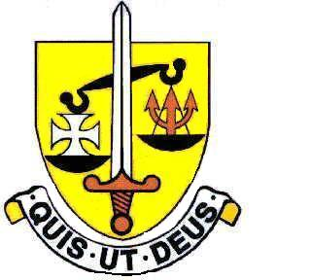 Voluntary Aided
North Finchley “An outstandingly effective School” Ofsted

London N12 7NJ
Tel: 020 8446 2256

Email: applications@st-michaels.barnet.sch.uk

4 Form Entry Voluntary Aided Grammar School for Girls with Boys in the Sixth Form
860 on Roll. 220 in Sixth Form.
Exam Invigilators/Cover Supervisors)
Barnet Unified Reward Grade C Max (currently £15.79 per hour)
Required to work as and when needed

Required as soon as possible.

The Governors are seeking to appoint Exam Invigilators & Cover Supervisors to work on a flexible basis.

Invigilators are required to ensure that examinations are conducted according to current regulations. Duties include ensuring the security of the examination before, during and after the process.

Cover Supervisors are required in classrooms across all subject areas where the teacher is absent. Duties include maintaining good order and keeping students on task.

Availability for both these positions can be negotiated with the School for those who wish to work particular hours/days of the week. Ideally suited to these roles are those with excellent communication skills and a highly organised approach.

A Support Staff application form and Job Descriptions are available on the school website.

Please send completed applications to applications@st-michaels.barnet.sch.uk.

We are committed to safeguarding and promoting child welfare
The post is subject to an enhanced DBS check
St Michael’s is an equal opportunities employer - applications are welcome from all sections of the community

