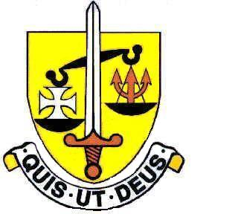

ST. MICHAEL’S CATHOLIC GRAMMAR SCHOOL

TERM DATES 2023/2024

AUTUMN TERM 2023
First Half: Monday 4th September - Friday 20th October
INSET Monday 4th September pm - Yr12 Enrolment
Tuesday 5th September - Year 7 start
Wednesday 6th September – Years 8-13 return

Half-term: Monday 23rd October – Friday 27th October

Second Half: Monday 30th October – Thursday 21st December
INSET Monday 30th October
Christmas holiday Friday 22nd December – Wednesday 3rd January

SPRING TERM 2024

First Half: Thursday 4th January – Friday 9th February
INSET Thursday 4th January
INSET Friday 5th January

Half-term: Monday 12th February – Friday 16th February

Second Half: Monday 19th February – Thursday 28th March
Easter holiday Friday 29th March – Friday 12th April
(Easter weekend 29th March to 1st April)

SUMMER TERM 2024

First Half: Monday 15th April - Friday 24th May
(May Day Bank Holiday: Monday 6th May)

Half-term: Monday 27th May – 31st May
(Spring Bank Holiday 27th May)

Second Half: Monday 3rd June – Friday 19th July

(Total number of Days 195 (includes 4 INSET Days plus 1 Disaggregated Day)

