ST.MICHAEL’S CATHOLIC GRAMMAR SCHOOL

Nether Street 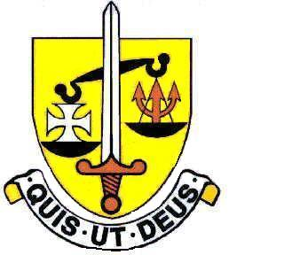 Voluntary Aided
North Finchley “An outstandingly effective School” Ofsted

London N12 7NJ
Tel: 020 8446 2256 Email: office@ st-michaels.barnet.sch.uk
Fax: 020 8343 9598 Website: www.st-michaels.barnet.sch.uk

16th July 2020

Dear parents,
Re: Head’s Letter to Parents – End of Summer Term
Thank you to all of you who contributed to the consultation on the Risk Assessment – please refer to the attached document which responds to all the areas raised.
Also attached to this letter is a document entitled “Back to School for Everyone” – and it is vital that every parent and student read this thoroughly. It is a brief and I hope very clear list of instructions about how we will operate in September to keep everyone safe, it is effectively our Risk Assessment in action. If regulations change such that we need to alter aspects of this document, then we will notify you before the first day in September. Please also note that the back page needs to be returned to St Michael’s either on the first day or just before.
We hope and pray that our return to school in September will not be interrupted by another lockdown – whether national, partial or local. Nevertheless, we are preparing for this eventuality should it take place. As you know, teachers have been actively developing their skills over the last couple of weeks and many students have had their first experience of live lessons – this is all part of our preparations for high-quality online provision should we go back into lockdown. The school is conscious that some families have struggled through these days of lockdown as a result of a lack of computer access. I will be writing to parents again in September to encourage those who have a spare or old laptop or computer they no longer require to donate it to the school so that we can give it to those families we have already identified as being without suitable computer access.
Thank you to the many students and parents who attended the school towards the end of last week to visit the grotto and write messages in the book of condolence. Mr and Mrs Carson and Victoria’s elder sister Isabella visited the school in private on Friday and spent time reading through the messages many of you left and admired the thousands of flowers brought in. Our prayers go out to Victoria and her family, may she rest in the peace of Christ.
These last dozen weeks or so have been very difficult for all sections of our school community – and we all need, both students and staff, to have a rest from online school. You may be concerned that your child has fallen behind over these last weeks – but I would ask you to refrain from making them work on school work during this holiday. Upon our return, we will be implementing our Recovery Curriculum and, within a short time, inviting those who need to to attend catch-up sessions. Teachers will judge whether their students have fallen behind and what action needs to be taken to support them – I am confident that, with dedicated teachers and hardworking students, we will be able to get our students back on track in working towards the aspirations and dreams they have for their futures.
I wish you all a restful and peaceful holiday,
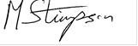
Michael Stimpson
Headteacher

