ST. MICHAEL’S CATHOLIC GRAMMAR SCHOOL
WELCOME TO OUR SIXTH FORM
(John 15:12)

AS I HAVE LOVED YOU”
“LOVE ONE ANOTHER

Mission Statement | 3
Introduction from Mr Stimpson, Headmaster | 4 – 6
General Information about St. Michael’s | 6 – 13
SUBJECTS OFFERED AT A LEVEL:
Art | 14
Biology | 15 – 17
Chemistry | 18 – 19
Economics | 20
English Literature | 21 – 22
French | 23 – 24
Geography | 25 – 26
Government and Politics | 27
History | 28
Italian | 29
Mathematics and Further Mathematics | 30 – 31
Physics | 32 – 33
Psychology | 34 – 35
Religious Studies | 36 – 37
Spanish | 38 – 39
CONTENTS:

A Voluntary Aided School in the Trusteeship of St. Michael’s Catholic School Trustee,
a Member of the Loreto Education Trust
Founded by the Sisters of the Poor Child Jesus

We seek to ensure that:
- St Michael’s is a Catholic school in which the Gospel message to “Love one another, as I have loved you” informs all aspects of community life.
- We are distinguished by the quality of education and care extended to all members of the school community.
- Each member of the school community is recognised as an individual and everybody is valued and enabled to fulfil their potential.
- In partnership with the wider community we are prepared to make full use of all the opportunities available so that we are all freed to become the best version of ourselves as God intended, and ultimately to create a better world.

MISSION

STATEMENT

The Sixth Form at St Michael’s

Introduction

There is no doubt about it, if you are one of St Michael's Sixth Formers you will have a different experience of sixth form life from that of a sixth form college or a college of further education, or even another school. Those who stay on into the Sixth Form know the staff and the staff know them well and can give advice and help with greater effectiveness. Those who join the Sixth Form from another school will find that special care is taken by everyone to make them welcome and get to know them. The size of the school and the size of the sixth form make this possible.

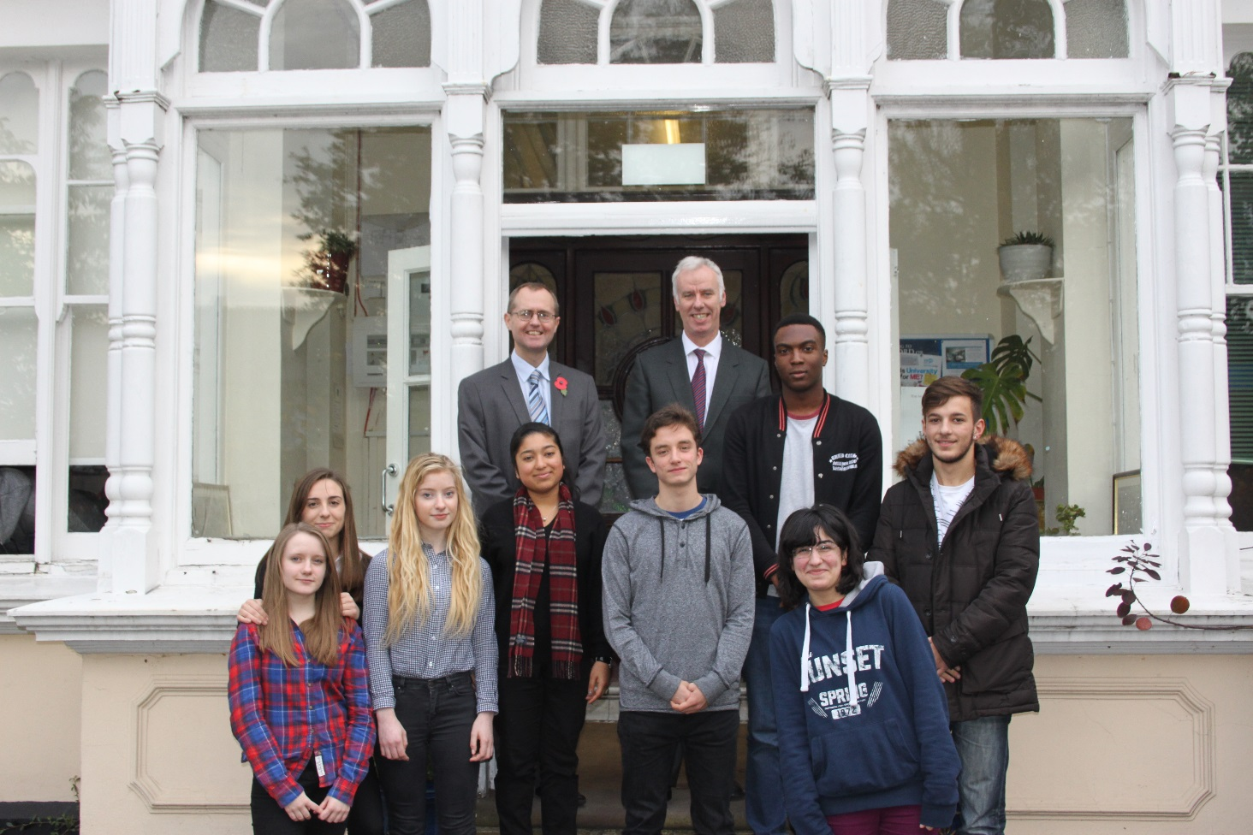

Mr Brian Roberts (Head of Sixth Form) and Mr Paul Ward (Deputy Head of 6th Form)

In addition, the Sixth Form have opportunities not only to grow in leadership skills among their peer group but also with the younger pupils. They clubs and activities for them, help Year 7 to settle in, assist with sports coaching or musical activities and charitable fund-raising - all of which enable us to write very full and complimentary UCAS references about a wider range of their abilities and successes.

Other leadership opportunities arise from being Sixth Form Councillors, “Guardian Angels”, Committee members, school magazine reporters and editors, librarians and catering organisers. The Sixth Form Curriculum also provides an opportunity for Community Service and Work Experience at home and abroad.

Overall in the Sixth Form you are treated as a young adult and we would expect you to have a reliable and responsible attitude to attendance, punctuality, study and general behaviour.

If you come to St Michael's Sixth Form you are not coming just for Advanced Level study, but for an educational experience that goes beyond this. We try to provide opportunities for development of the whole person in a wide variety of ways. We also take seriously the responsibility of training our students in the acquisition of good study habits which will be of the utmost importance in Higher Education.

Above all, St Michael's is a Catholic school, and has a strong emphasis on developing a caring, supportive Christian community among staff and students. In the Sixth Form we are often able to offer a few places to students who are not Catholic or Christian. However, it is expected that if you apply to stay on or to join the Sixth Form here, you are broadly in sympathy with the aims of the school and feel comfortable in an environment where Faith and Spiritual Development are taken seriously.

Students wishing to join Year 12 from outside:

- Need to make an undertaking to play a full part in the Catholic life of the school, i.e. take part in assembly, religious services and compulsory RE as well as a day of recollection/reflection.
You will be able to demonstrate this in your Personal Statement which you should bring with you when you meet with the Head of Sixth Form.
- Need to show a willingness to abide by the Sixth Form Regulations with particular regard to:
- Attendance
- Punctuality
- Attitude to authority and school rules
This will be demonstrated when you are invited to meet the Head of Sixth Form.
We will ask your present school for your predicted GCSE grades.

Your Studies

You need to realise that there is a marked difference between GCSE and Advanced Level. St Michael’s offers an academic curriculum leading to public examinations at Advanced Level. Our students pursue 3 subjects.

Remember that study at this level requires real commitment and only the highly motivated succeed. You will be expected to study at home for a minimum of:

- 3 hours a night from Monday - Friday ] in addition to study
- 5 hours on Saturday/Sunday ] undertaken in school

When selecting your Advanced Level subjects, try to balance the following factors:
Your interest in, and aptitude for, a particular subject
What occupation you may eventually decide to enter
The requirements of higher education

Remember to talk to the subject teachers concerned before making your choices.
The Careers Officer can also offer useful advice.
In this prospectus you will find details about each of the courses we offer. In addition, all students have R.E. lessons and a range of enrichment studies such as first aid, cooking for one, and self-defence.

Careers Guidance and Destinations of Sixth Formers

Careers guidance and advice is available from the Careers Officer, form tutors and subject teachers throughout your time in the school. Each student has the opportunity of a personal interview with the Careers Officer. An important aspect of Sixth Form life is the preparation for University. We assist the application process at every stage, providing time and support in researching and in the writing of your personal statement. In addition we offer specific help to those interested in Oxbridge, Law and Medicine.
Opportunities for work experience are encouraged during school time as well as in holidays, while Work Experience placements in Europe are made available and organised by the school.
Almost all of St Michael’s students go on to higher education covering the whole range of institutions but in particular Russell Group Universities. A number of students decide to take a year off before entering higher education and recent adventures have included voluntary work in Australia, Africa and Central/South America.

We are proud that many of our students have gone on to substantial achievement in a diversity of fields and make a positive contribution to society.

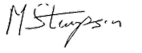
Mr M Stimpson
Headteacher

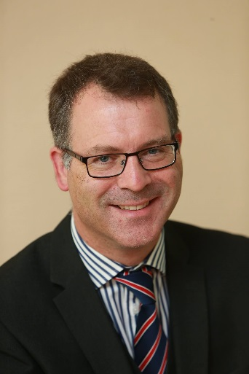

Sixth Form Admissions Policy

As a Catholic School we aim to provide a Catholic education for all our pupils. At our School Catholic doctrine and practice permeate every aspect of the School’s activity. It is essential that the Catholic character of the School’s education is fully supported by all families in the School. All applicants and are therefore expected to give their full, unreserved and positive support for the aims and ethos of the School.

Sixth Form Admission Requirements

All applicants to the sixth form must submit an application form by the date published on the school’s website, students who make a late application risk that all the places on the A Level courses of their choice will be full. Students must hold a conditional offer of a place which may be made following a Careers Information Advice and Guidance (CIAG) interview with the school. On GCSE results day, applicants holding a conditional offer must attend an enrolment interview with the school where the place may be confirmed if the published eligibility criteria have been met, the requirements are:

- Applicants should have achieved the equivalent of at least 6 GCSE passes at grade 7 or above including at least a level 7 in English Language and Mathematics.

- Applicants should also have at least a grade 7 at GCSE in the subjects (or those closely related to them) they wish to study at Advanced Level, as a grade 7 to 9 at GCSE are a necessary preparation for success at A Level. Where a GCSE subject has different components the School expects at least grade 7 in each component of a higher paper (where applicable). If students wish to study a subject at Advanced Level which they have not studied at GCSE then they will be expected to have at least a grade 7 in the most closely related subject(s): i.e. in English Language and Literature for English Literature, in English Language for Politics and in English and Maths for Economics. However, in creative or practical subjects like Art, a 6 may be acceptable if an applicant can demonstrate evidence of talent, aptitude and prior achievement in that subject area. There is also greater flexibility in Psychology where a grade 6 in English Language and Maths may be sufficient for the candidate who is highly motivated towards success in Social Sciences.

Sixth Form Oversubscription Criteria

Where the number of eligible students reaching the required standards in GCSE or equivalent exceeds the number of places available, priority for admission to the Sixth Form will be given as follows:

- Those who attended St Michael’s in Year 11
- Catholic girls and boys who are looked after or have previously been looked after. (Previously looked after children are children who were looked after, but have ceased to be so because they have been adopted or have become subject to child arrangements orders or special guardianship orders)
- Catholic girls and boys who exceed the minimum entrance requirements
- Non-Catholic girls and boys who are looked after or have previously been looked after.
- Girls and boys from other Christian denominations who exceed the minimum entrance requirements
- Other girls and boys who meet the minimum entrance requirements.

Application Procedure

Application forms for applicants from other Schools should be received by the School by 28 February. Applicants will be informed in writing whether the School is able to make them an offer of a place, or a place on the waiting list. Any offer will be provisional upon GCSE results. Students who make a late application run the risk that all the places on the A Level courses of their choice will be taken. The full Admissions Policy can be found on the school website.

Life in the Sixth Form

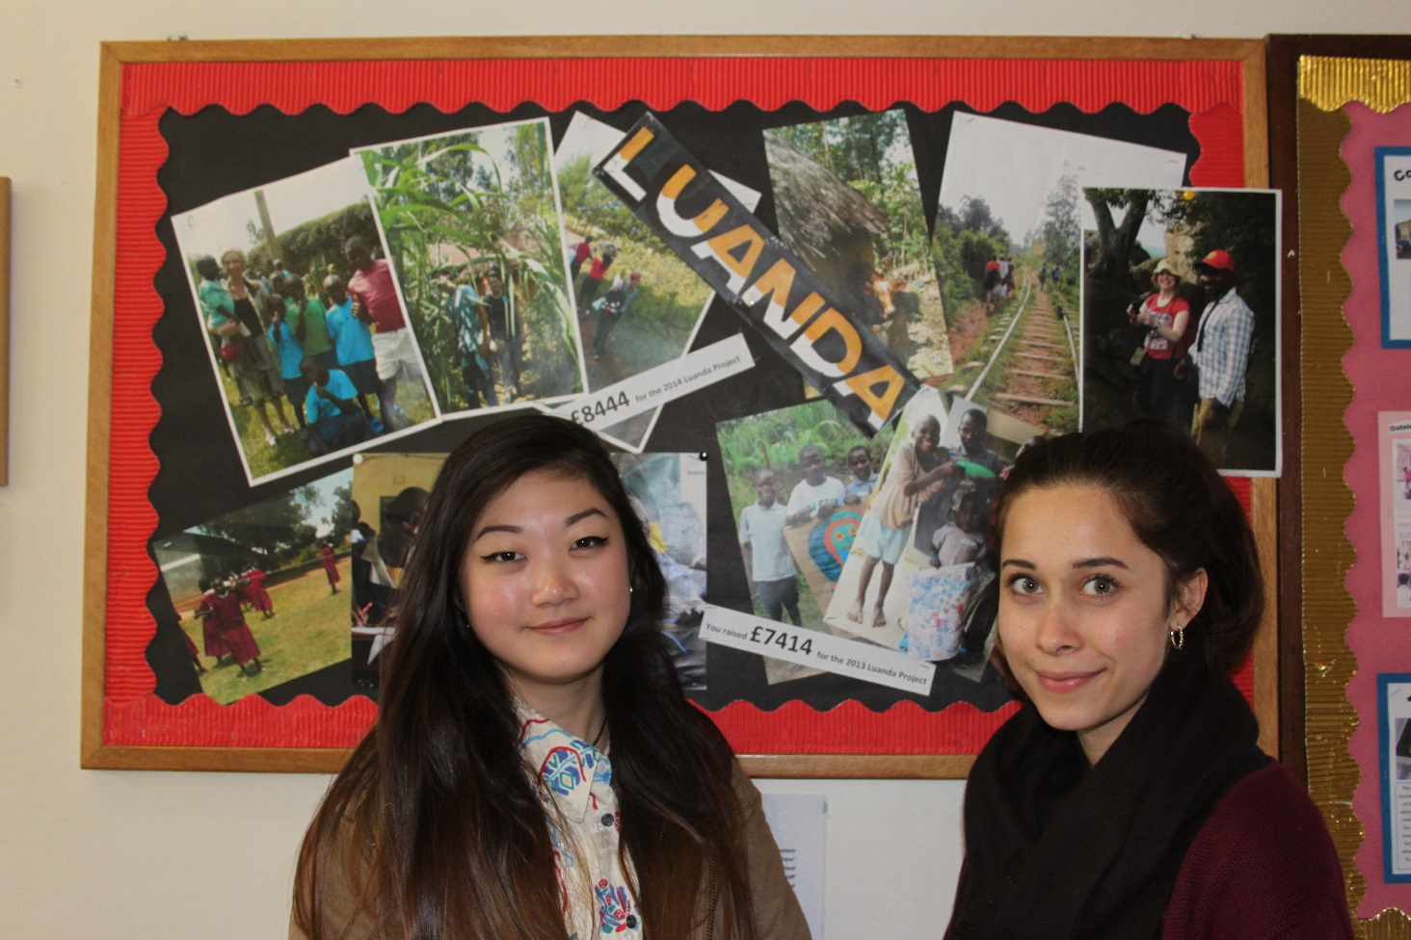

Year 13 students who went to our partner school in Kenya

Life in the Sixth Form is very different! You will find that you have to take much more responsibility for your own learning and for the way in which you conduct yourself. Your time in the Sixth Form is meant to be enjoyable and productive. We encourage independence but there must be clear procedures to enable the community to run smoothly. Before you commit yourself to two years of study here, we thought you might like to know what some of our expectations are:

1. Monitoring of Progress

It has been shown by various pieces of research that success at A Level is promoted by constant monitoring and review of progress.

At St Michael’s, we monitor the progress of our Sixth Formers by asking subject teachers each half term for each student’s predicted grades at that stage of the course. These can then be compared with expected attainment grades based on GCSE performance (ALIS grades). We ask for their comments on attitude, attendance as well as academic progress and set specific targets. These will be discussed at specifically arranged Mentoring interviews with Form Tutors. This will give both students and tutors a realistic idea of the progress being made - both what is going well and where further work is needed.

In Year 12, there will be formal assessments in September, November and January and exams in the Summer. Every student is expected to gain at least a grade B in these tests. Students must gain at least a Grade C at the end of Year 12 in a subject in order to progress on to A Level. However, any grade less than a B is considered to be poor performance. In Year 13, there will be assessments in the Autumn (November) and in the Spring (January).
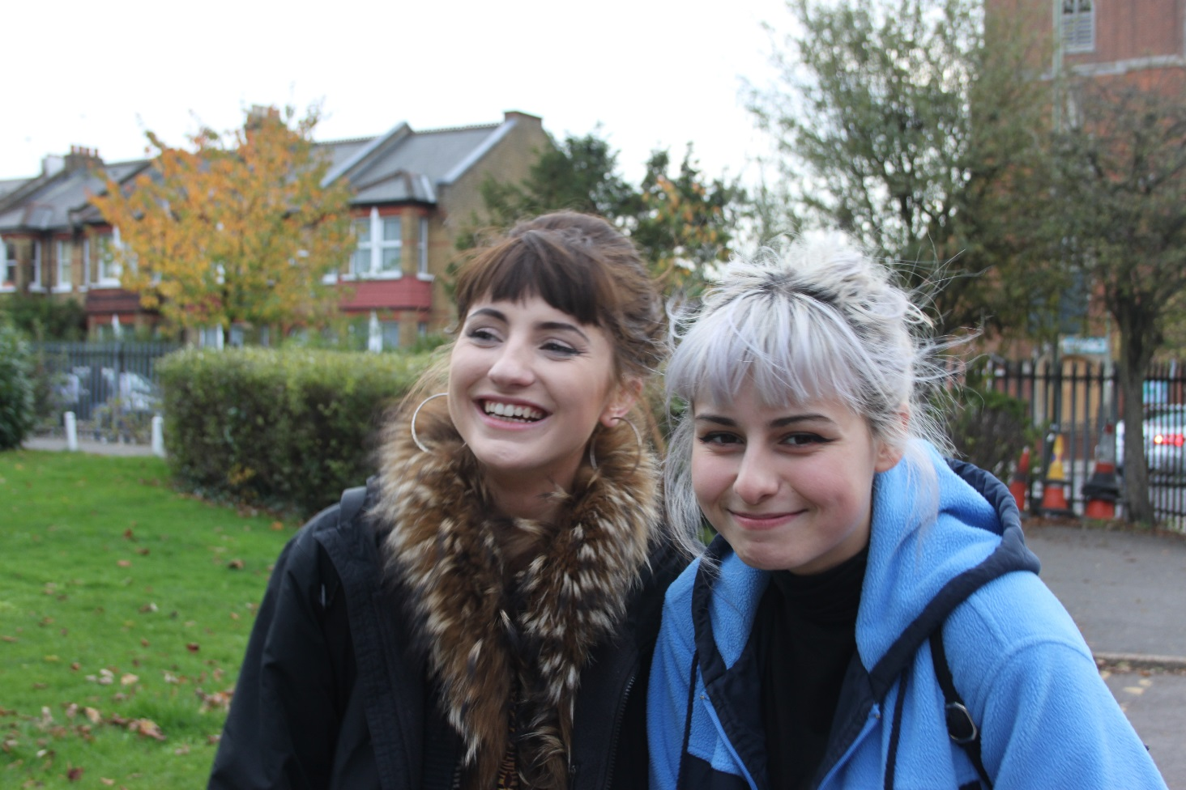

2. Dress Code

At St Michael’s, we expect our Sixth Formers always to dress in a way which is respectable, decent, tidy and appropriate for school, but there will also be occasions when they will need to dress more formally.

These guidelines give some indication as to what is considered to be appropriate:

Shorts, combat trousers and sportswear are not allowed. Leggings can only be worn with full length skirts.
Trousers and jeans must be plain, i.e. not torn and without loud or brightly coloured patterns or decorations e.g. patches, studs, fringes, chains, zips etc.
Trousers and jeans must be full-length and worn at waist height with no flesh or underwear exposed
Skirts must not be shorter than knee-length
- Headgear (hats, caps, headscarves and hoods) may not be worn within the school site
Unsuitably revealing clothing is not allowed, e.g. skin tight items, bare midriffs and shoulders and very low necklines
Loud or extravagant items of jewellery are not permitted: rings and studs may only be worn in ears and on fingers
• Hair may only be dyed a natural colour.

3. Study Privilege

The spirit of the Study Privilege is to encourage Sixth Formers to develop self-motivation and good study habits.

Year 12 During the school day, when the student does not have a lesson, they may study anywhere in the Grange, Library, or in the Sixth Form Resources Centre (excluding the Common Room). On one afternoon each week, when the student has no timetabled lessons, they may leave school at the end of the morning, after period 5 (12.55), on receipt of a letter from their parents which acknowledges that they know that their daughter/son will not be in school on that afternoon. If there is a whole school occasion, such as Mass, or if requested to do so by a member of Staff, everyone is expected to remain in school on that afternoon.

Year 13 Students with Study Privilege may study in any free room, in the Library or the Sixth Form Resources Centre (excluding the Common Room). On receipt of a letter from their parents, they may also study at home on two afternoons when they have no timetabled lessons.

If subject teachers report at any time during the year that work is not being completed satisfactorily or there is concern over punctuality or attendance, the Study Privilege will be withdrawn.

4. General Sixth Form Issues

When you enter the Sixth Form, you become more responsible for your own learning, which means catching up with work when you are away, for example, on European Work Experience, foreign exchanges or residential field trips. Also be prepared for lessons at lunchtime and after school!

Smoking is not allowed on the school premises or in the near vicinity of the school as smoking outside school sets a bad example to the younger pupils.

Sixth Formers are permitted to leave the premises without permission during break and at lunchtime. If a student has a special reason to leave the premises, other than for a previously agreed appointment, she should seek the permission of the Head or Deputy Head of Sixth Form. All Sixth Formers leaving the premises during school time must sign out and sign in. There is a book for this purpose in the School Office.

Sixth Formers are permitted to bring mobile phones into school providing they are switched off during lesson times and are only used in the Sixth Form buildings, out of view of the younger pupils.

The Grange – A brief history

The Sixth Form of St Michael's is housed in its own building, known as The Grange. A Finchley landmark, this was the original house occupied by the Sisters of the Poor Child Jesus who purchased it in 1908. At that time the house, stables and grounds occupied five acres and one of the earliest headmistresses described it as follows:

"The views from the windows were too enticing to start work immediately... (we are) delighted with the magnificent grounds, flowers, palms, decorative plants, shrubs......we would gladly have stayed longer in the garden..."

Although the grounds have changed considerably since those days, many of the interesting and unusual trees they enjoyed still grace the lawn next to the house.

In 1980, the Sisters gave the school over to lay control but have retained the trusteeship. Strong links therefore remain as does a legacy of great generosity and dedicated teaching.

The Grange was acquired for use as a Sixth Form centre in 1988 and the elegant living rooms have been adapted for use as both form and subject bases. In 1998, many of these rooms were refurbished. Specialist facilities for other subjects are housed in the main School buildings.

The Conservatory, or "winter garden" as it was originally called, was rebuilt in 1999 and the exterior of the Grange was redecorated in 2015. There is also a Sixth form common room where snacks and coffee may be prepared.

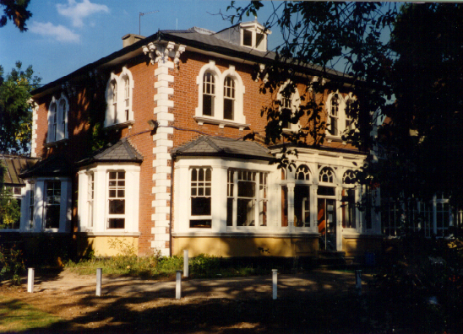
The Mary Daly Sixth Form Resource Centre

To assist all students with their studies, the school has always put considerable investment into resources, both traditional and modern.

Through the Library all have access to electronically stored learning resources and information. There are also computers available for student use in the Library and the computer rooms. Resources Officers assist students to find information, with the presentation of work and in the use of the desk top publishing facilities and graphic design facilities.

However, with the expanding size of our Sixth Form, in 1996 we realised the need for more accommodation. We were also eager to promote the use of information technology and independent learning initiatives so the Resources Centre was built: a two storey building on the site of the old convent laundry. As well as providing a conference area for the sixth form, it also houses a much greater range of educational technology and a network of personal computers solely for use by Sixth Form students including connection to the internet. Such facilities provide learning support materials, data and equipment which match that provided by even the best higher education institutions. From September 2015 6th Form students have benefited from a refurbishment of these facilities to provide a doubling of capacity for access to ICT on the ground floor.

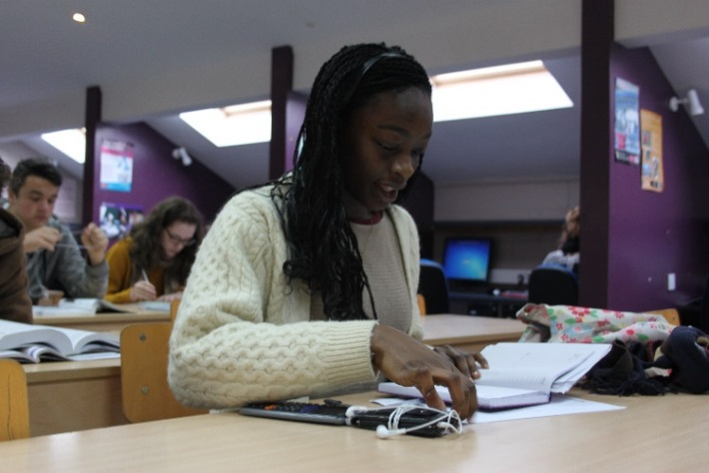
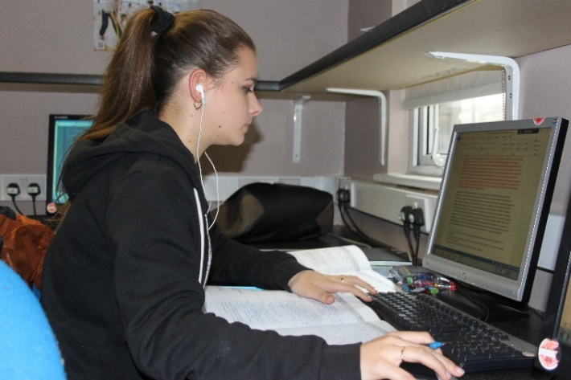

Students during private study in the 6th Form Centre

Advanced Level study:

At St Michael’s, we expect students to take 3 subjects, except for those who are choosing Further Maths who must take 4, which are studied for the duration of the Sixth form (i.e. normally 2 years) leading to Public Examinations at the end of Year 13.

What do our students say about us?

These comments were made by Year 13 students in answer to a confidential and anonymous questionnaire administered by the Advanced Level Information System at Durham University.

“I am glad to have stayed at St Michael’s after GCSE and that I did not go elsewhere. I have both benefited from the experience and enjoyed it.”

“I am very satisfied to have done my A Level course here. It has given me very many opportunities. They keep you on your toes!”

“I’m glad I came to St Michael’s for the Sixth Form. It has been a good learning experience. The teaching is great and the atmosphere is friendly with a good sense of community.”

“I feel that this school has taught me a lot about self-discipline. St Michael’s was the right choice for me as the structure and support provided by the teachers is very much what I need to work to my full potential.”

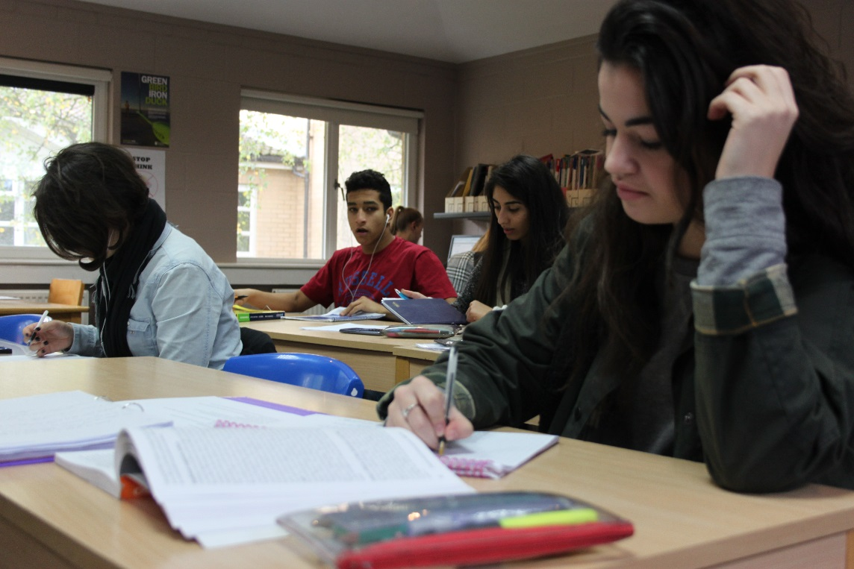

“The teaching is excellent here. There are regular assessments and the staff are willing to provide extra help if the student is unsure about a piece of work. Everyone is motivated and wants to go to university.”

“The school is very supportive and ambitious for its students. It makes them believe in themselves and that they can achieve their goals.”

“The teachers here are highly skilled and very helpful. They are the best thing about the school.”

“There is a wide range of subjects and the school tried to accommodate whatever subjects we wanted to do.”

“The school upholds its Christian belief and helps the students to develop moral values. The Masses are lovely.”
Art

The Art course encourages a broad approach to the subject, allowing students to continue and develop their understanding of the genre on a critical and highly experimental level.
This course builds on the knowledge, skills and understanding acquired by candidates taking Art at GCSE level. Candidates with a good GCSE pass rate will have developed the sufficient understanding and skill required for their programme of study. The course forms the ideal basis for further study at Foundation and Degree level, and many students go on to careers in interior and industrial design, architecture, fashion, photography and computer animated design.
Students explore and refine a range of ideas, skills and materials to develop their own visual explorations on the theme of the Human Form and the Abstract. Particular focus is given to drawing, contextual analysis and critical reflection. Students go on to develop their initial ideas through refinement and experimentation within their practical outcomes. To coincide with this, their contextual awareness is manifested within the form of a written personal study: a critical essay.
Assessment is frequent and rigorous so as to identify areas for development and provide information to design individualised support for pupils beyond the lesson.
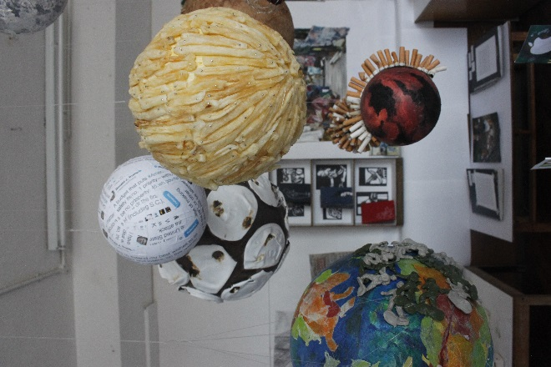
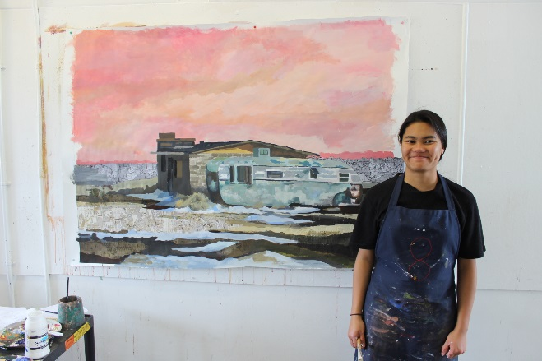
Trips to Galleries both teacher led and independent form an integral part of the course, enabling heightened critical analysis and cultural awareness. To support careers in the arts two pupils are selected each year to participate in the Royal Academy of Arts ATTRACT Programme. This is an invaluable opportunity to make links with industry professionals and practicing artists. Pupils regularly succeed in btaining places on Foundation and Degree courses. All pupils wishing to apply to art colleges are given support with portfolio preparation and interview guidance.

Biology (AQA)

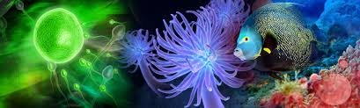

Biology at A-level is an exciting and in-depth look at how life works; how the molecules that make up all living things are constructed and work together and how whole organisms and communities are adapted to survive. This subject is ideal for students with a fascination with living things & a keen, enquiring and analytical mind. I will encourage you NOT to study this subject if you solely need Biology for university/career (e.g. medicine) without love or interest for it – therein lies failure and a fast route to repeating year 12.

This subject is complemented superbly by chemistry – all those serious about the A-level should consider this carefully as non-chemists can be at a disadvantage. Biology also complements Psychology and Geography well.

Entry requirements:

We require A-level biologists to have 2x “7” grades at GCSE dual science minimum. If separate sciences were studied then we require 2x “7” grades in biology and chemistry. This being said, due to the conceptual leap between GCSE and A-level, 8-9 grades at GCSE are preferred for taking on this subject. At St. Michaels we study the AQA Biology specification [7402 (A-level] the main topics of which are summarised below:
- Biological Molecules:

Explore how chemical elements make up all the essential molecules that permit life! Analyse the structure and function of proteins and how they interact within the body. Investigate the chemical nature of DNA & explore how DNA replicates within cells. Describe the structure of lipids & carbohydrates and explain why water has such weird properties which make it essential for life.
- Cells:

Observe, describe and draw living cells and their microscopic organelles. See the difference between eukaryotic and prokaryotic cells; investigating how each is able to reproduce. Analyse how microorganisms can infect a larger organism and how that organism’s immune system is designed to deal with the invaders.
- Exchange of substances with the environment:

Investigate how both plants and animals are built to be able to transport materials around their bodies effectively & efficiently including the function of the respiratory and circulatory systems in animals and the mass transport systems in plants. Explore how processes such as diffusion govern the structure of exchange organs including the digestive system and the lungs.

- Genetic information, Variation & relationships between organisms:

Explore how DNA codes for features of all organisms and is able to construct proteins via ribosomes. Analyse how mutations arise and how this is essential for providing variation in life; thus explaining the mystery of how evolution occurs. Investigate evolution in its scope for sculpting new beings, providing the diversity of life and how biodiversity is important.

Energy transfers in and between organisms

Explore how life depends of the continuous transfer of energy, starting with the biochemical pathway of photosynthesis and being passed on to other organisms in the food chain. Explain how the process of respiration occurs in high detail and why energy transfer processes are not 100% efficient.
- Responding to changes in environment

Explaining how and why organisms respond to changes in their internal & external environment, and how achieve this response. Investigating how a nerve transmits a signal, how hormones govern internal messaging and how the body achieves a constant internal environment.
- Genetics, populations, evolution and ecosystems

Analysing the close link between the genetic and proteomic structures of organisms to investigate their degree of relatedness in evolutionary history. Identification of species and being able to say how populations change over time in order to evolve into separate species, and how competition between organisms can shape these interactions.
- The control of gene expression

An in-depth look into how the genetic code can be manipulated in order to achieve different outcomes such as cell differentiation. Explore how epigenetic factors can modify which genes are expressed and how mutations alter the underlying genetic code. Apply this knowledge to see how DNA can be artificially manipulated in order to produce genetically modified organisms or to identify individuals through DNA analysis.

Key skills:

• A logical mind with an aptitude for thinking about the big picture.

• An ability to remember complex nomenclature

• A flair for creative planning.

• A resilient and dedicated approach to systematic study.

• An ability to assimilate a high volume of factual material & be able to express such material in context.

Assessment:

Assessment at A-level takes place over the course of 3 written papers sat at the end of year 13:

Paper 1 – 2 hours of questions from topics 1-4 including relevant practical knowledge. [35%]

Paper 2 – 2 hours of questions from topics 5-8 including relevant practical knowledge. [35%]

Paper 3 – 2 hours of synoptic questions from all topics of the course including a 25 mark essay question. [30%]

Career Possibilities:

Include, but are by no means limited to: all medical professions, biological research, ecology, education, television documentary making, business/finance, law, farming & animal husbandry, catering, even archaeology! When all is said and done, biology closes very few doors in life.

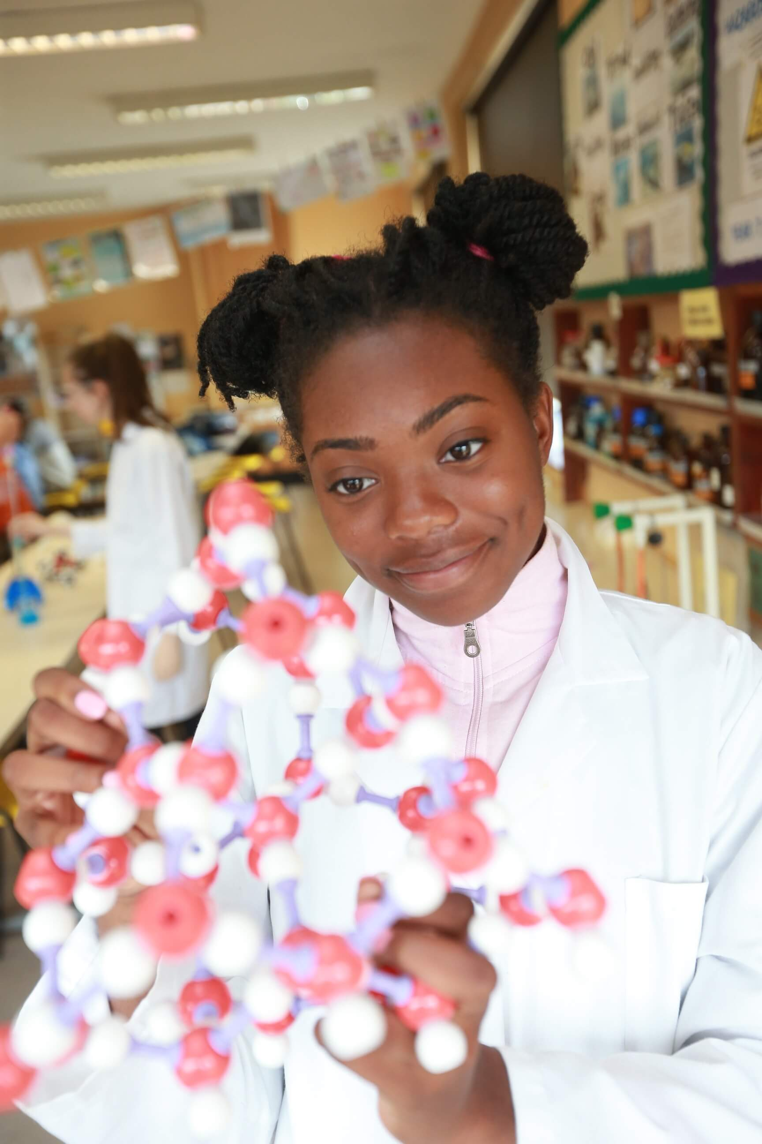

Chemistry (EdExcel)

Are you interested in:
- how new and useful substances are made
- modern theories about the structure of the atom
- how cells and batteries work
- the molecules which occur in nature
- learning how to analyse the composition of a mystery liquid?

Do you enjoy:
- experiments which test your powers of observation or your accuracy
- using maths to predict the outcome of chemical reactions
- learning how to use the periodic table to understand patterns amongst the elements?
- want to learn about ‘green issues’ from a chemical perspective?

Chemistry - often referred to as the 'Central Science' - is important for the study of many other sciences including geology, materials science, biology, textile science, food science and the medical sciences.

We follow the Pearson Edexcel Exam Board specification. The A Level qualification consists of three externally examined papers sat at the end of the two year course leading to the 'A' level qualification. This modern syllabus provides a demanding and stimulating course covering topics in Physical, Inorganic and Organic Chemistry. Students acquire an in-depth understanding of the patterns and trends linking elements, compounds and their reactions. There is an emphasis on the relevance of the chemistry studied to industry, to everyday life and to environmental issues. A practical session is held each week.

The topics covered include:-

Year 12

• Atomic structure & the periodic table

• Bonding and structure (ionic, covalent and metallic)

• Redox

• Inorganic Chemistry & the periodic table

• Formulae, equations and amounts of substance.

• Organic Chemistry

• Modern analytical techniques

• Energetics

• Rates of reactions

• Reversible reactions.

There is no coursework element assessed but students will carry out sixteen core practicals which will lead to them achieving competence in core practical methods.

Year 13 (A level)

Paper One: Advanced Inorganic and Physical Chemistry (30% of A-Level assessment)

• Atomic structure and the periodic table

• Bonding and structure (ionic, covalent and metallic)

• Redox, Inorganic Chemistry and the periodic table

• Formulae, equations and amounts of substance

• Energetics, Equilibria

• Transition metals.

Paper Two: Advanced Organic and Physical Chemistry (30% of A-Level assessment)

• Bonding and structure

• Formulae, equations and amounts of substance

• Organic Chemistry, Modern analytical techniques

• Energetics

• Rates of reactions, Reversible reactions,

Paper Three: General and Practical Principles in Chemistry (40% of A-Level assessment)

Questions in this paper may draw on any of the topics in this specification. The paper will include synoptic questions that may draw on two or more different topics listed.

The paper will include questions that assess conceptual and theoretical understanding of experimental methods (indirect practical skills) that will draw on students’ experiences of the core practicals.

Teaching

The teaching is shared between two teachers of Chemistry. The study of this subject involves, each week:-
- 3 hours teaching
- 1½ hours practical work
- 5 hours homework:
  - background reading
  - questions set by each teacher each week
  - writing up the practical experiment

Students are given regular short tests on each topic, to provide information on progress during the course.

Assessment

A level Chemistry: Papers 1, 2 and 3 Year 13

Careers

Advanced Level Chemistry is usually essential for the following degree courses -

Medicine, Biochemistry, Agricultural Science, Chemical Engineering, Materials Science, Dentistry, Veterinary Science, Pharmacy, Pharmacology and Geology. Chemistry supports the study of many topics in Biology and Physics.

Economics

The study of Economics will help you develop a critical and analytical approach, which will challenge any preconceived notions held about how the economy works. Consider these important questions: How will Brexit impact the British economy? Why the gap between rich and poor? What caused the Financial Crisis in 2008? Is Google too powerful? Why are globalisation and free trade out of favour? Is immigration detrimental to the economy? What are the impacts of a single European currency?

If these questions intrigue you, then Economics will provide you with a way of analysing them. You will be introduced to a number of formal, theoretical models in order to analyse the world. You will be expected to think independently about particular economic issues and discuss your views.

The course is designed to introduce new theories to students with no previous experience of studying Economics; however, an appetite for current affairs is essential. The examinations and class discussions are based on the economic phenomena reported every day in the media. The course is challenging as it introduces a new and logical way of looking at the world. It is important to be open-minded and allow yourself to step back from the discussion and evaluate the assumptions it may be resting on.

The course is split up into two main areas:

Microeconomics, the study of individual markets and the decisions firms and consumers make within them. Topics included are:

• demand and supply

• labour markets

• theory of the firm (monopoly, oligopoly, game theory)

• market failure and externalities

Macroeconomics, considers the performance of the economy as a whole. Topics studied include:

• macroeconomic objectives (economic growth, inflation, unemployment, and income inequality)

• aggregate demand and aggregate supply

• globalisation

• the European Union and economic integration

• economic development

Understanding the economy is important both when operating a business or when policymaking in government. However, the intellectual skills developed will be of life-long value:

• Ability to extract and interpret complex data

• Present a coherent argument on paper

• A good grounding in how the national and international economy works

The Edexcel A-level Specification is assessed with three public examinations which require a range of skills, from essays to the analysis of unseen case studies.

English Literature (AQA)

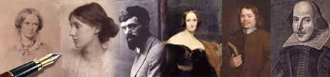

Introduction

The English Department prepares you for Literature examinations at Advanced Level. This particular specification provides you with the opportunity to extend your experience of the variety and richness of English Literature and to practise attentive, sensitive reading and analysis. As the course is entirely literature based, a love of reading is an essential requirement. Please be aware that there is no English Language element in the specification, although it is essential that you are able to write well in order to achieve a grade C or above. Your teacher will give you advice about planning and structuring your essays but it is crucial that you acquire and use the appropriate language and critical terms for writing about literature.

Specific Entry Requirements

The Department adopts the school’s expectations that students come to English with a minimum of a grade 7 at both Language and Literature GCSE. Moreover, we expect students to be natural, independent readers, with demonstrable ability and passion for the subject.

Exam Board – AQA; Specification - English Literature: A (Specification code: 7711 & 7712)

Main Topics

• Love through the Ages: Shakespeare, Poetry and Prose.

• Texts in Shared Contexts: First World War and its Aftermath- Prose, Drama, Poetry.

• N.E.A. (Non-Examination Assessment)- 2 texts; 1 of which must be pre 1900.

• Note that N.E.A. is through coursework.

Key Skills

The variety of assessment styles used, such as passaged-based questions, unseen material, single text questions, multiple text questions, open and closed book approaches, allows you to develop a wide range of skills, such as to read critically, analyse, evaluate and undertake independent research.

Assessment

You will be expected to write essays under timed conditions for examination practice. In September and November of Year 12, there are departmental tests which are used to measure your progress and indicate your suitability for the course. In addition, mock examinations will be held across all subjects in January of years 1 and 2 of the A Level course. You can expect one essay every two weeks.

N.B. N.E.A features only at A Level.

Career Possibilities

English A-Level is required for entry to read English at university but it is also of great benefit in communication and media courses as well as future employment. It is recognised as a suitable qualification to show competence to study at a higher level, so that it can be used like most A Levels, to meet the entrance requirements for a range of subjects, including Law, Accountancy, History, Philosophy and so forth. You should not think of it as limiting to one kind of work. English graduates enter a range of careers, for example, journalism, law, teaching, the universities, theatre, publishing, photography, the trade unions and even medicine.

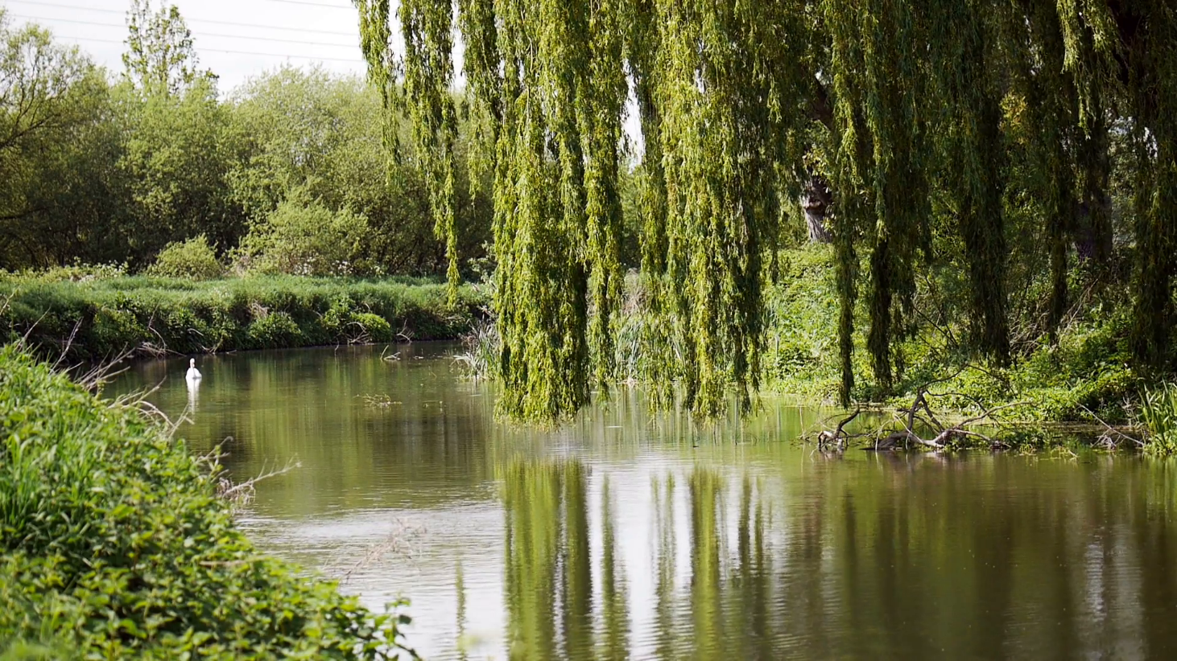

French (AQA)

“If the UK is to engage fully with the wider world in business, diplomacy and academia we need more young people studying languages.” - Dr Wendy Piatt, Director

General of the Russell Group. It hasn’t been a more exciting time to deepen your knowledge of French. It is estimated that the total number of French speakers will be approximately 500 million people in 2025 and 700 million people by 2050, according to the Organisation Internationale de la Francophonie (around one tenth of the estimated world population). Nevertheless, the value of learning a language cannot be reduced to numbers, the French language is one of the many expressions of the cultures and societies it relates to and it make us want to learn more about it.

Entry requirements

You will need to have achieved at least a Grade 7 in your French GCSE exam. It will lead you to a linear A level exam.

Specification for AQA

The A Level specification builds on the knowledge, understanding and skills gained at GCSE and constitutes an integrated study with a focus on language, culture and society: how French-speaking society has been shaped, socially and culturally, and how it continues to change. It fosters a range of transferable skills, including communication, critical thinking strong research skills and creativity. The course is divided in 4 main themes and sub-themes and you must in addition study one text and one film which will be chosen by the department. You will also have to carry an individual research project which will be assessed as part of your speaking examination.

Aspects of French-speaking society: current trends

• The changing nature of the family (La famille en voie de changement)

• The 'cyber-society' (La « cyber-société »)

• The place of voluntary work (Le rôle du bénévolat)

Aspects of French-speaking society: current issues

• Positive features of a diverse society (Les aspects positifs d'une société diverse)

• Life for the marginalised (Quelle vie pour les marginalisés ? )

• How criminals are treated (Comment on traite les criminels)

Aspects of political life in the French-speaking world

• Teenagers, the right to vote and political commitment (Les ados, le droit de vote et l'engagement politique)

• Demonstrations, strikes – who holds the power? (Manifestations, grèves – à qui le pouvoir ?)

• Politics and immigration (La politique et l'immigration)

Artistic culture in the French-speaking world

• A culture proud of its heritage (Une culture fière de son patrimoine)

• Contemporary francophone music (La musique francophone contemporaine)

• Cinema: the 7th art form (Cinéma : le septième art).

Assessment

The exam consists of three papers:
  - Paper 1: Listening, reading, translation into English and French (100 words min per passage). 2 hours 30 minutes. 40% of your exam.
  - Paper 2: Writing on one text and one film or two texts. 2 hours, 300 words per essay. 30% of your exam.
  - Paper 3: Speaking. 16-18 minutes + 5minutes prep. Respond to 1 stimulation cards from 1 sub-theme. 2 minutes presentation and 10 min discussion on individual research project. 30% of your exam.

Key skills

In order to be successful in your study of French at A level, you will need to show great organizational skills, flexibility and curiosity of mind, passion and the ability to lead independent research.

Career Possibilities

Education: School Teacher, University Lecturer, Language/Class Assistant.

Business: International relations Consultant, Foreign Correspondent, Proof-reader Importer/Exporter, International Account Manager, International Banking Officer, Bilingual customer support.

Culture/Tourism: Cultural Events Coordinator, Travel Agent, Translator/Interpreter/Guide.

Government: National Security Agent, Immigration Officer, Court Interpreter, Cultural Attaché, UNESCO Official, Translator/Interpreter, Foreign Diplomat, Foreign Service Officer.

Geography (EdExcel)

Is this the right subject for me? Do you...

• Want to study a subject that focuses on 21 Century issues such as the rise of superpowers and increasing global problems such as climate change

• Have a curiosity about the world’s places, peoples and environments

• Have an interest and concern for the environment

• Want to study a topical subject focussing on current affairs and enjoy thinking independently

• Enjoy studying a subject that is relevant to your own lives and experiences

• Want an opportunity to carry out practical work outdoors as well as classwork

• Enjoy asking questions and finding your own answers

• Want to broaden your studies to cover both ‘science’ and ‘humanities’

• Enjoy travel and finding out about new people, places, landscapes and events

• Want to keep their options open for university or career choices

What will I learn?

The world we live in is changing. Geography allows you to see why and how it is changing. It can enhance communication skills, literacy and numeracy, IT literacy, spatial awareness, team working, problem solving and environmental awareness.

You will study global themes, including globalisation and natural hazards. You will discover how your own actions can relate to the wider world, be it your local area or a country far away. You will study for the following units and assessment will take place in June 2019:
Paper One (30%)  Exam: 2 hours 15 minutes | Paper Two (30%)  Exam: 2 hours and 15 minutes
You will study a range of topics such as Tectonic Processes and Hazards, The Water Cycle and Water Insecurity, The Carbon Cycle and Coastal Landscapes | This paper will include: Globalisation, Superpowers, Regenerating Places and Global Development
Paper Three (20%)  Exam: 2 hours and 15 minutes | Independent Investigation (20%)
In this unit you will be prepared for the demands of higher education and employment. You will study synoptic themes which will help you to see ‘the  bigger picture’, by making geographical links between topics and issues. | You will be required to carry out an Independent Investigation, using fieldwork skills gained over the course. In order to help you prepare, a week long visit to Margam Park in South Wales will be undertaken. The investigation will be assessed by your teachers and moderated externally.

Exam Board: EDEXCEL/PEARSON

Possible careers:

Marketing, finance, retail, law, advertising, education, and environmental management. This is not an exhaustive list as Geography is a versatile and well sought after subject by employers. As a subject it allows you to keep your options open for both university and future careers.

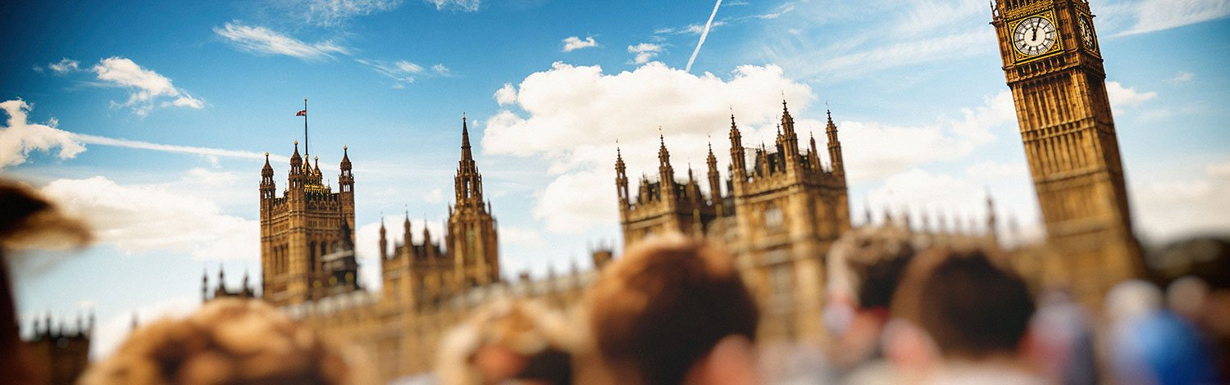
Government and Politics

The Politics Department teaches the Edexcel examining board syllabus in Government and Politics. The first year gives a good grounding in the fundamentals of British Politics with core political ideas. The course consists of three modules. Unit 1 is a study of Democracy and Participation; Political Parties and Elections. Unit 2 includes a study of the UK Constitution, Parliament, the Prime Minister, Cabinet and more political ideas such as: anarchism, feminism, multi-culturalism and nationalism.

Unit 3 students study the USA political system. This unit consists of: the Constitution and Federalism, Congress, Presidency, Supreme Court, democracy and participation, civil rights.

What skills are you going to acquire?

• Develop critical thinking skills and the ability to interpret, evaluate and comment

• Develop a critical awareness of the nature of politics and the relationship between political ideas, institutions and processes

• Acquire knowledge and understanding of the structures of authority and power within the political system of the United Kingdom, and how these may differ from those of other political systems

• Acquire knowledge and informed understanding of the rights and responsibilities of the individual Develop an interest in and engagement with contemporary politics

Trips:

- House of Commons

- Supreme Court

- Numerous visits and outside lectures in LSE and King’s College

- Numerous visits to politicians (MPs and Peers)

Expectations

Expectations are high. Each student is expected to meet or exceed her/his own individual grade potential. This is indicated from data based on GCSE grades and an aptitude test conducted around September. This is called the ALIS grade.

No prior knowledge of politics is expected. That said, a genuine interest in the conduct and outcome of elections and the nature of the political process in Britain is vital. A willingness to read a quality newspaper each day, subscribe to a periodical, like the Economist and watch the news daily are essential practices for success in Politics A Level.

Full attendance at lessons, punctuality and the ability to meet deadlines are required qualities. In lessons the willingness to enter into a discussion and share your own knowledge and opinions is expected.

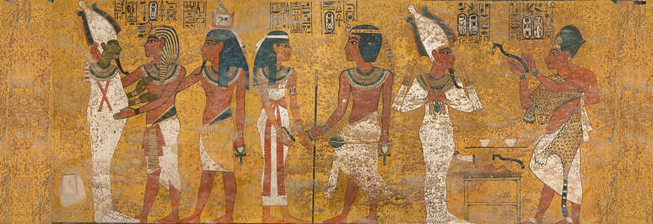
History (AQA)

History is the analysis of evidence from the past in order to find out and explain what happened. It involves the arrangement of information about events and trends in history in such a way that conveys understanding of the significance of events and the pattern of history. It involves the construction of a narrative of history. It requires the ability to explain and analyse the causes and consequences of historical events.
The study of A Level History
- Develops the ability to weigh evidence. Students are required to handle the evidence critically and link the content of documents with the provenance of the evidence. Students are trained to apply such documentary evidence to the study of a particular enquiry.
- Explores the claims of different interpretations of History and considers the merits of contrasting views of history.
- Encourages clarity of thought, speaking and writing and especially the organisation of clear, logical arguments or judgements about History, to express an opinion convincingly. Students write a narrative of events which makes sense of the unfolding pattern of history.

St Michael’s offers the following A Level History course
AQA A Level History
Paper 1: Stuart Britain and the Crisis of Monarchy 1603-1702. One end of course paper with 3 exam questions. Two essays based on a critical understanding of different key issues of the period. One question requiring students to evaluate different authors and their divergent interpretations of the period. 40%
Paper 2: The Transformation of China 1936-1997. One end of course paper with 3 exam questions. Two essays based on a critical understanding of different key issues of the period. One question requiring students to evaluate different primary source material and understand its value for an enquiry into a particular issue. 40%
Coursework: A single answer to a student generated question. The Non-Examined Assessment (NEA) must cover a period between 100 and 120 years. The question can focus on an issue within that period but must take into account the context of the whole period. Students must make use of a t least two historians whose interpretations provide different ways of understanding the period. Students must also make use of a t least 3 cotemporary documents from the period which their must apply to their answer.
The department is well resourced in terms of books and DVD resources. Attending lectures and educational visits are organised and encouraged as a means of broadening the acquisition of knowledge. The Department plan to visit Paris as part of the study of the French Revolution.
Italian (EdExcel)

What is the course about?
The aims of the course are to enable the students to:

- enhance their linguistic skills and promote and develop their capacity for critical thinking on the basis of their knowledge and understanding of the language, culture and society of Italy and the Italian speaking world
- develop control of the language system to convey meaning, using spoken and written skills, including an extended range of vocabulary, for both practical and intellectual purposes as increasingly confident, accurate and independent users of Italian
- engage critically with intellectually stimulating texts, films and other materials in the original language, developing an appreciation of sophisticated and creative uses of Italian and understanding them within their cultural and social context.

The exam board is EDEXCEL; this course is linear, with 3 papers to be sat at the end of Year 13: Paper 1: Listening, Reading and Translation (2 hours, paper code: (9IN0/01)
Paper 2: Written response to works and Translation (2 hours and 40 min, paper code: 9IN0/02) Paper 3: Speaking (21-23 minutes, paper code: 9IN0/03)

What topics will be covered?
- Theme 1: changes within Italian society (changes within the Italian family, education, world of work)
- Theme 2: political and artistic culture within the context of Italian speaking countries and/or communities (music, media, cultural heritage).
- Theme 3: Italy: a society in evolution (positive impact and problems caused by immigration, the North/South divide)
- Theme 4: from Fascism to nowadays (the advent of Mussolini, Fascism during the Second World War, the six nations).

In addition, students will study two discrete Italian works: either two literary texts, or one literary text and one film (all taken from the prescribed literary texts and films list provided by the exam board).
Finally, each student is required to undertake an independent research project that must relate to the Italian-speaking cultural and/or social context; it should be based on a subject of interest of the students’ choosing, but may be on any of the four themes of study of the specification.

What career opportunities?
There is a wide range of job opportunities. They fall broadly into two categories:

- those directly concerned with languages, e.g. teaching, interpreting and translating.
- those with fluency in a foreign language is an additional required skill: e.g. in accountancy, law, insurance, marketing, banking, tourism and travel, secretarial work and librarianship.
Mathematics and Further Mathematics (EdExcel)

Mathematics is not only a subject in its own right, it is also a service subject. If you want to study Physics or Psychology, Architecture or Accountancy, Geography or Geology, a solid knowledge of Mathematics will help. The Mathematics course reflects these needs as Mechanics and Statistics topics are studied.

In all areas of Mathematics, you will extend your range of mathematical skills and techniques through problem solving, tackling investigations, teacher exposition, discussion and consolidation of work. You will develop resourcefulness in solving problems, the ability to apply Mathematics in unfamiliar situations and to solve problems for which methods are not readily available. Work will be regularly set, though you will take more responsibility for your own learning and you will be expected to do weekly individual work on each topic.

Students wishing to extend their study in Mathematics are given the opportunity to study A-level Further Mathematics.

A level Mathematics
The subject content for A-Level Mathematics is 100% prescribed by the DfE. All students will be assessed on their knowledge of Pure Mathematics, Mechanics and Statistics. The A level Mathematics is linear course, examined at the end of the course.

In Pure Mathematics, topics covered are: proof, algebra and functions, coordinate geometry in the (x,y) plane, sequences and series, trigonometry, exponentials and logarithms, differentiation, integration, numerical methods and vectors.

In statistics and probability, the following topics are covered: statistical sampling, data presentation and interpretation, probability, statistical distributions and statistical hypothesis testing.

In mechanics, four topics are examined: quantities and units in mechanics, kinematics, forces and Newton’s laws and moments.

We follow the Pearson Edexcel Exam Board specification. The Mathematics A-Level qualification consists of three externally examined papers
- Paper 1: Pure Mathematics 1, 33% of the total marks, 2 hours, 100 marks in total
- Paper 2: Pure Mathematics 2, 33% of the total marks, 2 hours, 100 marks in total
- Paper 3: Statistics and Mechanics, 33% of the total marks, 2 hours, 100 marks in total across two sections: Section A: Statistics (50 marks) Section B: Mechanics (50 marks)

A level Further Mathematics
The A-level Further Mathematics qualification is challenging and highly prestigious and is essential for any student thinking of studying Mathematics at University. It has also proved very useful to students preparing for University courses with a sizeable mathematics input, including sciences at Oxford and Cambridge. It is a very challenging and rewarding A level.
A level Further Mathematics has 50% of the content prescribed by the DfE. On top of the compulsory pure further mathematics topics, our students cover further mechanics and decision mathematics. The A level Further Mathematics is linear course, examined at the end of the course.
In Pure Mathematics, topics covered are: matrices, further algebra and functions, further calculus, further vectors, polar coordinates, hyperbolic functions and differential equations
In Further Mechanics, the following topics are covered: momentum and impulse, work, energy and power, elastic strings and springs and elastic energy, elastic collisions in one dimension and elastic collision in 2 dimensions.
In Decision Mathematics, four topics are examined: algorithms and graph theory, algorithms on graphs, critical path analysis and linear programming
We follow the Pearson Edexcel Exam Board specification. The Further Mathematics A Level qualification consists of four externally examined papers:
- Paper 1: Core Pure Mathematics 1, 25% of the total marks, 1 hour 30mins, 75 marks in total
- Paper 2: Core Pure Mathematics 2, 25% of the total marks, 1 hour 30mins, 75 marks in total
- Paper 3: Further Mathematics Option 1: Further Mechanics 1, 25% of the total marks, 1 hour 30mins, 75 marks in total
- Paper 4: Further Mathematics Option 2: Decision Mathematics 1, 25% of the total marks, 1 hour 30mins, 75 marks in total

Career Possibilities
Whether you continue further study at University or enter employment at the end of the sixth form, you will find that having studied Mathematics at A-level your choices and opportunities will be immense.

Mathematics is a subject widely studied at universities. It may be studied as a single subject or as part of a joint honours degree course, in conjunction with Biology, Chemistry, Geography, Physics, Philosophy, Computer Studies and many other subjects. Mathematics also has a major input into a number of other courses including Medicine, Psychology and Economics.

The skills used by a mathematician are highly valued in Industry and Business, and consequently employers look for potential employees with a Mathematics qualification. Mathematics is a useful and highly regarded subject and is well worth the effort involved. The syllabus is varied and interesting and will enable you to acquire knowledge and skills with confidence, satisfaction and enjoyment.

Physics

Why study A-level Physics?
An A-Level in physics shows that you are able to apply your mind logically when solving problems. The world of engineering, science, medicine and many non-scientific careers beckon budding scientists. Physics will help you develop a flexible portfolio of skills that will equip you for a satisfying career wherever your ambitions lie.

What qualifications are needed?
It is not essential to study A-Level Mathematics. However, a high level of numeracy is required and demands that students have a sound knowledge of basic Maths.

EDEXCEL A-Level Physics May/June 2020 - The A-level exam consists of 3 externally assessed exams

Paper 1- Advanced Physics I -
- Assessment is 1 hour 45 minutes.
- The paper consists of 90 marks.
- Contributes 30% to overall qualification

This paper will examine the following topics:
Working as a Physicist; Mechanics; Electric Circuits; Further Mechanics; Electric and Magnetic Fields; Nuclear and Particle Physics.

The paper may include multiple-choice, short open, open-response, calculations and extended writing questions. Students will be expected to apply their knowledge and understanding to familiar and unfamiliar contexts.

Paper 2- Advanced Physics II -
- Assessment is 1 hour 45 minutes.
- The paper consists of 90 marks.
- Contributes 30% to overall qualification

This paper will examine the following topics:
Working as a Physicist; Materials; Waves and Particle Nature of Light; Thermodynamics; Space ;Nuclear Radiation; Gravitational Fields; Oscillations

- A minimum of 40% of the marks across the three papers will be awarded for mathematical calculations
- Students will be expected to apply knowledge and understanding to familiar and unfamiliar contexts
- The paper will include questions that assess conceptual and theoretical understanding of experimental methods (indirect practical skills) that will draw on students’ experiences of the core practicals.

Paper 3- General and Practical Principles in Physics -
- Assessment is 2 hours 30 minutes.
- The paper consists of 120 marks.
- Contributes 40% to overall qualification
- Questions in this paper may draw on any of the topics in this specification.
- The paper will include synoptic questions that may draw on two or more different topics.
- The paper includes questions that assess conceptual and theoretical understanding of experimental methods.
- A minimum of 40% of the marks across the three papers will target mathematical skills

Science Practical Endorsement
Internally assessed and externally moderated.

Students use relevant apparatus and techniques to develop and demonstrate specific practical skills assessed through a minimum of 12 core practicals.

Students will be assessed separately for the Science Practical Endorsement. The Endorsement will not contribute to the overall grade for this qualification, but the result will be recorded on the student’s certificate.

You will become a member of a friendly Physics Department, which delivers excellent results. You will acquire the skill of organising your study time efficiently. Each hour in class is backed up by an hour of private study comprising of problem solving, practical write-ups and background reading. During the course you will be expected to attend outside lectures and courses. We trust that studying Physics in St. Michael’s will be a rewarding experience. You will be following in the footsteps of many students who today are successful medics, lawyers, engineers, city financiers, architects and CERN particle physicists.

“Whatever you want to be in life, Physics will help you achieve it”

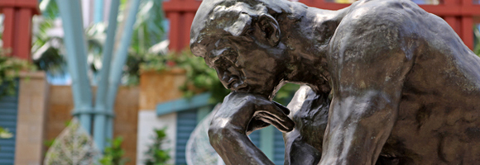
Psychology (AQA)

Introduction
Psychology can best be described as the study of the mind and behaviour in humans and animals. Throughout the course the emphasis will be on studying and analysing behaviour and applying the findings to everyday human interaction. It will take the student on a journey from the birth of an infant and the attachment behaviour associated with being dependent on others through to the development of memory within individuals. Along this journey the student will learn about abnormalities within humans such as schizophrenia, aggression and other types of illnesses. In summary the whole complex process of being an individual and understanding other individuals within a complex and ever changing society is fundamentally at the heart of studying Psychology at both AS and A-level.

Entry requirements: Five Grade 7 at GCSE as well as at least a Level 6 in Maths and English

Exam Board: AQA

Specification: Psychology A-level (7182)

Main topics

Paper 1: Introductory Topics in Psychology:
Section A: Social Influence
Section B: Memory
Section C: Attachment
Section D: Psychopathology
Paper 2: Psychology in Context
Section A: Approaches in Psychology
Section B: Biopsychology
Section C: Research Methods
Paper 3: Issues and Options in Psychology
Section A: Issues & Debates in Psychology
Section B: Relationships or Gender or Cognition and Development
Section C: Schizophrenia or Eating Behaviour or Stress
Section D: Aggression or Forensic Psychology or Addiction

Key skills
Literacy, numeracy, information technology, analytical skills and communication skills.

Assessment
Assessment takes the form of 2 examination papers for AS level and three for A-level. There is no coursework at present for the award of either of these courses.
Careers
Psychology at A-level can be used as a useful introduction to further courses and careers such as: medicine, education, industrial relations, communication studies, social and community work, personnel and lots of careers where understanding human interaction is an essential feature. Following Psychology as a career can lead to employment within a variety of settings such as occupational, educational, sports, counselling, criminological or within a clinical setting working in hospitals.

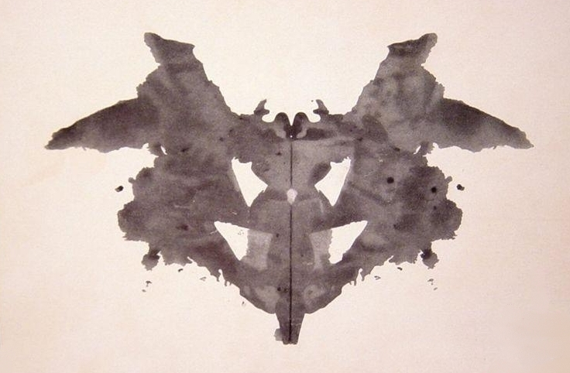

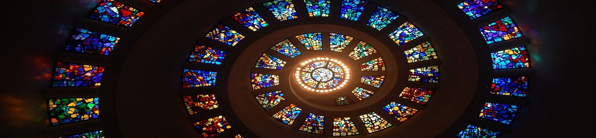
Religious Studies

Would you like to learn to think critically and learn to argue persuasively?

This course offers an opportunity to explore the rational basis of faith, and to consider some of the arguments offered for and against religious belief.

It is an introduction to philosophical thinking and its application to religion. You will study ultimate questions of a philosophical and ethical nature such as If there is a god why does evil exist? Is there any for the existence of God? Do humans have freewill or is everything determined? It introduces you to the root questions underlying all human life: Who? What? Where? How? When? Why?
These are the questions we have inherited from the ancient Greek philosophers that all people continually ask.

In ethics we ask ‘what is the right thing to do’? We look at what we mean when we use words such as ‘good’, ‘bad’, ‘ought’, ‘must’. How do I decide what is morally right and morally wrong? What answers have been offered to these questions?

We will study three areas:
- Philosophy of Religion – rational reflection on faith today and a study of ‘big’ questions.
- Ethics – consideration of different approaches to moral issues with application to specific issues.
- New Testament Studies – an examination of the context, authorship, interpretation and revelation of Jesus in the New Testament.

Candidates for A-Level study three modules (each worth 33.3% of the qualification) across years 12 and 13 which will be examined (in three 2 hour exams) in June of Year 13.

The following topics will be studied:
Philosophy of Religion
- Philosophical issues
- Nature and influence of religious experience
- The Problem of evil and suffering
- Philosophical Language
- Philosophers
- Influences and developments in philosophy
Ethics
- Significant concepts in issues and debates
- Utilitarianism, Situation Ethics and Natural Moral Law
- Applied Ethics: War and Peace and Sexual Ethics
- Ethical Language
- Ethical Theory (including comparison of 2 scholars)
- Medical Ethics
New Testament Studies
- Contexts of the New Testament
- Texts and Interpretation of the Person of Jesus
- Interpreting the text, the purpose and authorship of the 4th Gospel
- Ways of interpreting scripture
- Texts and interpretation
- Scientific and historical challenges in faith and history

Requirements
You must be able to express yourself clearly and logically in an intelligent argument and to reach a critical evaluation of different positions.
You must enjoy reading and should read widely around topics to develop different perspectives, as well as stay abreast of ethical and philosophical topical stories in the media.
This is an essay-based course so you should have excellent writing skills! You will need to have achieved at least a grade 7 in GCSE Religious Studies.

Assessment
One essay or extended piece of work is set every two weeks in alternate sections. These are graded in accordance with the criteria of the examining board so that you can assess your own progress.
There is lively debate in class and the occasional spot test.
Nearer to the exams there are tests under exam conditions for you to check how ready you are.

What does the course offer you?
Insights into your faith which can become much more mature.
An introduction to philosophy – there have been several students who have gone on to study philosophy and/or theology at university including Oxbridge.
An introduction to the great Christian theologians, especially Augustine and Aquinas and including some of the more recent ones.
An opportunity to debate current ethical issues and to learn to defend your own position.
An awareness of objections to religious belief and an indication of possible answers to these.

Any university welcomes evidence that you have developed skills allowing you to think logically and critically.

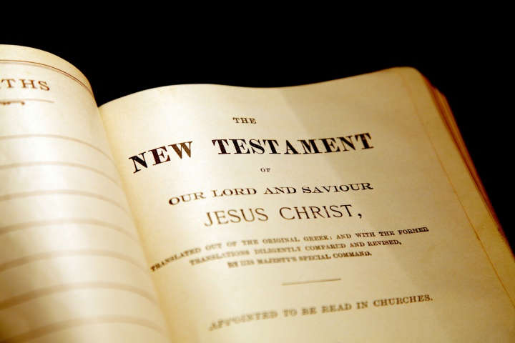
Many careers, such as medicine, law, education, the civil service, all accept a philosophical background.
Spanish (AQA)

Introduction
- The A-level Spanish course comprises stimulating content to enable students to develop their linguistic skills alongside their understanding of the culture and society of the countries where Spanish is spoken.
- Spanish is the third most widely spoken language on Earth after Chinese and English.
- There are 33 countries in the world that list Spanish as an official language.
- Spanish is one of the six official languages of the United Nations.

Entry Requirements - Candidates must achieve a Grade 7 at GCSE level.

Exam Board and Specification - AQA

Main Topics
Social Issues and Trends
- Modern and traditional values (Los valores tradicionales y modernos)
- Cyberspace (El ciberespacio)
- Equal rights (La igualdad de los sexos)

Artistic Culture in The Hispanic World
- Modern day idols (La influencia de los ídolos)
- Spanish regional identity (La identidad regional en España)
- Cultural heritage or cultural landscape (El patrimonio cultural)

Multiculturalism in Hispanic Society
- Immigration (La Inmigración)
- Racism (El Racismo)
- Integration (La Convivencia)

Aspects of Political Life In The Hispanic World
- Today's youth, tomorrow's citizens (Jóvenes de hoy, ciudadanos de mañana)
- Monarchies, republics and dictatorships (Monarquías, repúblicas y dictaduras)
- Popular movements (Movimientos populares)

In depth knowledge of a film or text as specified by your teacher

Key Skills
- Knowledge of the grammar and structures specified for GCSE must be secure.
- Understand and respond to authentic written and spoken material.
- Ability to write and speak spontaneously in Spanish.
- Show knowledge and understanding of, and respond critically to, different aspects of the culture and society of countries/communities where the language is spoken.

Assessment
Assessment tasks will be varied and cover listening, speaking, reading and writing skills. There is no coursework for A-level Spanish. All assessment is completed in public exams during the summer public exams session. An external examiner will carry out the oral exam and this can take place any time during a 5-week window in April-May as prescribed by AQA.

A-Level Exams
Paper 1: Listening, reading and writing (no dictionary permitted) Exam duration: 2hr30mins; Weighting of paper: 40%

Paper 2: Writing (no dictionary permitted or access to the text studied) Exam duration: 2h; Weighting of paper: 30%

Paper 3: Speaking (no dictionary permitted)
Exam duration: 21–23 minutes (including 5 minutes supervised preparation time);

Career Possibilities
A selection of possible careers available to those with Spanish degrees:
- Education: School Teacher, University Lecturer, Language/Class Assistant
- Business: International relations Consultant, Foreign Correspondent, Proof-reader Importer/Exporter, International Account Manager, International Banking Officer, Bilingual customer support
- Culture/Tourism: Cultural Events Coordinator, Travel Agent, Translator/Interpreter/Guide
- Government: National Security Agent, Immigration Officer, Court Interpreter, Cultural Attaché, UNESCO Official, Translator/Interpreter, Foreign Diplomat , Foreign Service Officer

