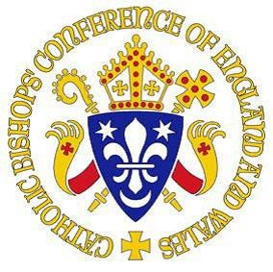
BISHOPS’ CONFERENCE OF ENGLAND AND WALES

CERTIFICATE OF CATHOLIC PRACTICE

Details of child (for identification only)
Full name of child: ____________________________________________________
Address of child: _____________________________________________________
___________________________________________________________________
Postcode: ___________________ Date of Birth: ____________________________

I am [the child’s parish priest] [the priest in charge of the Church where the family practises] [delete as applicable]
I hereby certify that this child and his/her family are known to me and, to the best of my knowledge and belief, the child is from a practising Catholic family.

Priest’s name ____________________ Position ___________________________
Parish (or ethnic chaplaincy) ____________________________________________
Address ____________________________________________________________
Priest’s signature

________________________________________

Date_______________________

Parish stamp or seal

Date__________________________ Telephone_____________________________

This form should be returned directly to the Headteacher at St. Michael’s by the closing date stated on the associated Supplementary Information Form. Failure to complete it or return it would prevent the Governors applying their Admissions Criteria to your Application for a place at St Michael’s for your daughter.
FORM 2

