ST. MICHAEL’S CATHOLIC GRAMMAR SCHOOL

Nether Street 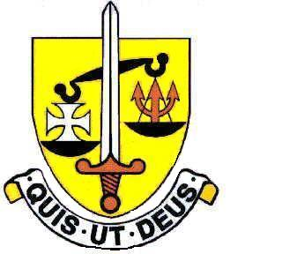 Voluntary Aided
North Finchley “An outstandingly effective School” Ofsted

London N12 7NJ
Tel: 020 8446 2256 Email: office@ st-michaels.barnet.sch.uk
Fax: 020 8343 9598 Website: www.st-michaels.barnet.sch.uk
4 Form Entry Voluntary Aided Grammar School for Girls with Boys in the Sixth Form
890 on Roll. 250 in Sixth Form.
Assistant Headteacher (2 posts)
1 x Head of KS3, 1 x Head of KS4
(Applicants can express a preference for a Key Stage or make an open application)
Leadership Group L13 to L17 Outer London
Required for September 2025.
The Governors invite applications for these important positions joining a successful Senior Leadership Team at this selective school which has been five times judged OUTSTANDING by OFSTED, the most recent Inspection being November 2022. The school was judged Outstanding in a Catholic Schools Inspection in October 2024. These two roles have arisen, one due to retirement and one due to internal promotion, offering exciting opportunities for school leadership and providing excellent preparation for Headship.

The postholders will take responsibility for the pastoral and academic care of students across Key Stages 3 or 4 assisted by Deputy Heads of both Key Stages. Areas of responsibility will be negotiated in response to the specific skills and experience the successful applicant brings, together with the needs of the school and in conjunction with the Senior Leadership Team.

We are seeking to appoint well-qualified professionals of proven experience who:
- Are committed to developing the School’s Catholic ethos, eager to lead the students and staff in prayer and capable of delivering aspects of the Core RE programme in the Sixth Form.
- Have an ability to work in partnership with the Headteacher and two Deputy Headteachers to maintain and improve the quality of teaching and learning.
- Have the intellect to initiate and manage change.
- Have strong proven managerial and leadership skills.

The school provides a very rewarding working environment where employees are valued and there is a focus on staff welfare.

An application form and job description are available on the school website and should be sent to applications@st-michaels.barnet.sch.uk. If interested in either position, one application is sufficient.

Closing date: Tuesday 22nd April 2025 – midday. Early applications are encouraged as we reserve the right to call candidates to interview before this advert is withdrawn.
We are committed to safeguarding and promoting child welfare
The post is subject to an enhanced DBS check
St Michael’s is an equal opportunities employer - applications are welcome from all sections of the community

