ST. MICHAEL’S CATHOLIC GRAMMAR SCHOOL

Nether Street 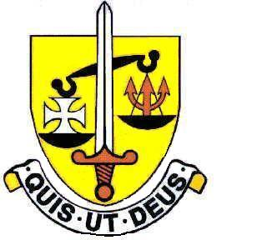 Voluntary Aided
North Finchley “An outstandingly effective School” Ofsted

London N12 7NJ
Tel: 020 8446 2256 Email: applications@st-michaels.barnet.sch.uk

4 Form Entry Voluntary Aided Grammar School for Girls with Boys in the Sixth Form
890 on Roll. 250 in Sixth Form.
Administrative Assistant
Unified Reward Grade B - Actual salary £21,815 to £22,127 (FTE £29,763 to £30,189)
Subject to Pay Award pending
30 hours per week, 39 weeks per year
Monday to Friday - 9am to 3.30pm

Required 1st September 2025

The Governors are seeking to appoint an Administrative Assistant to assist with a wide range of duties in the busy main school office. Duties will include (amongst others): administration linked to student data, including: Free School Meals and Pupil Premium; authorised absences; student references; school trips and events, Receptionist cover duties (in their absence), support with student attendance, support with finance administration, First Aid.

This person will work under the direction of the Office Manager and will be an intrinsic part of the school office team. Ideally suited to this role would be someone with excellent communication skills and a highly organised approach. Reliability and an enthusiastic outlook to problem-solving are key to this role. The appointed candidate will be flexible in their approach to the wide-range of work undertaken by the office and be able to prioritise their workload. Computer skills are essential as Word, Excel, SIMS, SchoolComms are used extensively in this role. In addition, a very good level of both written and spoken English are essential.

St. Michael’s is a vibrant school with a distinctive Catholic ethos. Students at the school are very well behaved and the school is a very rewarding working environment. Employees are valued and there is a focus on staff welfare.

A Support Staff application form and job description are available on the school website. Please send completed forms to applications@st-michaels.barnet.sch.uk. Please note we do not accept CVs as a method of application.

Closing date: Monday 7th July midday – interviews will be that week.

We are committed to safeguarding and promoting child welfare
The post is subject to an enhanced DBS check
St Michael’s is an equal opportunities employer - applications are welcome from all sections of the community

